Existing headsets
High end:
- Oculus Quest $633
- Sony PlayStation $350
Low end:
- Source: https://www.sodapdf.com/blog/best-vr-headset/
- Google Cardboard: under $20, connects to an app, no head strap
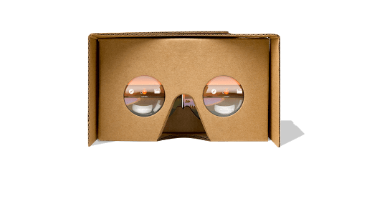
- Google Daydream View: casing to put your phone into, price ranges around $100
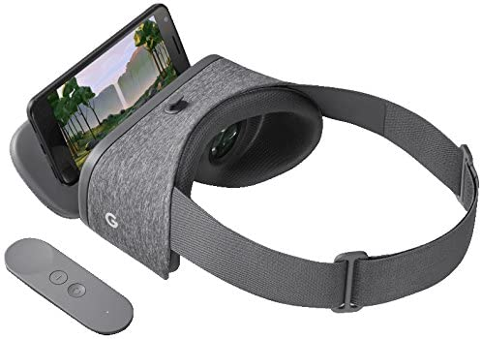

QTI Crypto Engine Core
https://csrc.nist.gov/CSRC/media/projects/cryptographic-module-validation-program/documents/security-policies/140sp2614.pdf

Microsoft Hololens 2

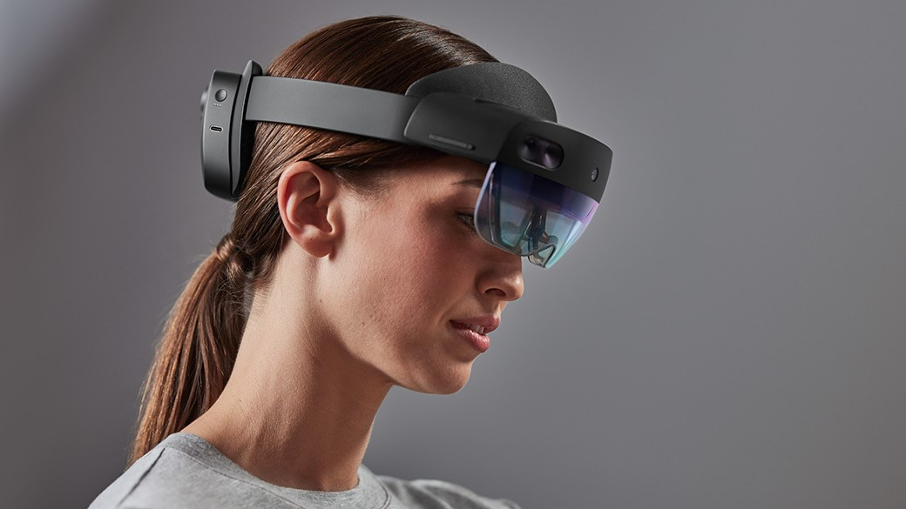

- Iris scanner
- Wireless
- Development resources/Documentation for app development here
- $3500 per device
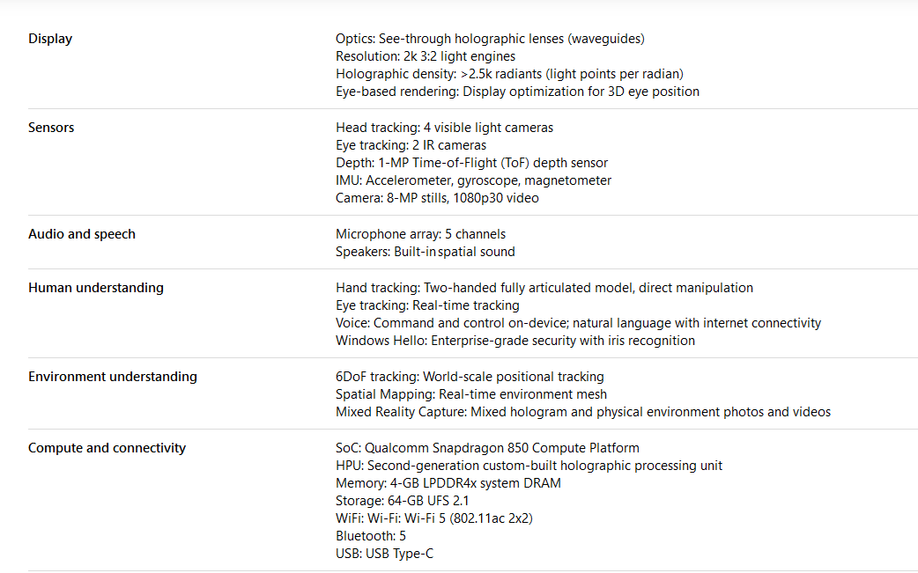

Vuzix
Various different devices. Looks like a lot run off of android
https://www.vuzix.com/products/
Vuzix blade cheapest option at $500

Displelix
https://www.dispelix.com/
- Appear to be selling waveform + projector
- Development kit available
- Little information about product/development for device
- Price not shown on website, would need to contact them (Probably expensive then)
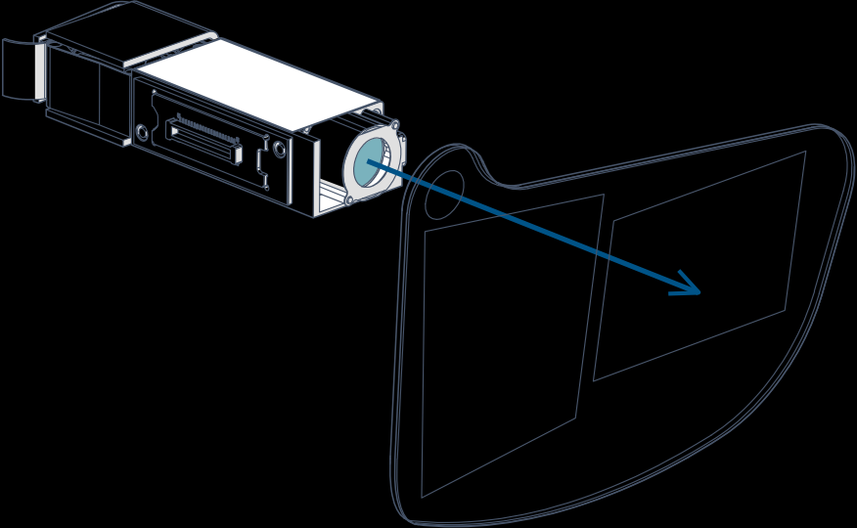

https://next.reality.news/news/build-your-own-ar-headset-using-leap-motions-open-source-project-north-star-design-0185151/

https://leapmotion.github.io/ProjectNorthStar/mechanical.html
-- open source AR headset

https://developer.leapmotion.com/northstar

https://github.com/leapmotion/ProjectNorthStar

https://www.smart-prototyping.com/AR-VR-MR-XR/AR-VR-Kits-Bundles
- Dev kits for project north star. Can buy all components needed for $500, can buy assembled and calibrated headset for $800 I believe. Open source AR with community-curated guides. Could be very helpful. Needs to be driven by outside source though - ie. computer or possibly a cellphone?

